The United Republic of Tanzania Development Report
How Tanzania Has Progressed

2008
Lisa Boyd, Nora Diehl, Jason Kramer

3/20/2008

Table of Contents

Introduction -Page 1

Definition of Development -Page 3

Education -Page 5

Health -Page 10

Basic Needs -Page 17
Economy -Page 24

Politics -Page 28
Economic Issues and Analysis -Page 33

Conclusion -Page 47

Introduction
The purpose of this paper is to assess the current development potential of the United Republic of Tanzania. Through the analysis of living standards, economic standing, and the current attempts at progress, we prove that Tanzania has the potential to improve the quality of life of its inhabitants but not to overcome its debt burden. The people of Tanzania are disadvantaged as a result of poor education systems, health problems, and a failure to meet basic needs. While Tanzania has made progress toward growth and development, it continues to be greatly hindered by its increasing debt burden and its poor standard of living.

Definition of Development
Every person on this earth is entitled to lead a stable and healthy life, without fear of natural or human-induced tragedies. It is the duty of the first world to aid the less-advantaged third world. The current economic and political status of developing nations is often the fault of the developed nations themselves. The instability of the third world has great potential to disrupt the global system and causes instability for the world as a whole. Creating a foundation focused on decent quality of life is the basis for any healthy society.
Development, therefore, must consist of economic growth as well as improvement in standard of living, two factors which can be interrelated. Standard of living includes all factors that determine a person’s quality of life: having access to clean water, enough food, healthcare adequate enough to keep an entire family healthy, shelter, at least the most basic education, etc. Without such basic needs, a human is deprived of his or her capability to live a full and productive life.
Though improving basic needs is paramount to development, a growing economy can facilitate this progress. Economic growth can not be the sole focus of developmental policy, however, because all members of society do not necessarily benefit from an increase in overall GDP of a country. Modernization theory stipulates that less developed countries strive to emulate developed countries by adopting similar policies. It measures economic improvement utilizing increases in GDP per capita and levels of industrialization as the basis for development. This theoretical approach fails to explain why increasing GDP per capita is ideal or how it improves the living standards of the average person. Development is instead rooted in the provision of social welfare which constructs a healthier society.
Tanzania is an East African nation which is battling many of the social and economic issues that have been contributing to underdevelopment in other nations. Tanzania’s relatively stable political history has reduced the hazards of violence and disruption that are more tangible elsewhere in Sub-Saharan Africa. Throughout this paper Tanzania is consistently compared to Kenya, South Africa, and sub-Saharan Africa. We chose Kenya due to its superior social and economic standards, while South Africa is a beneficial point of comparison because it has a stronger economy than both other countries. Sub-Saharan Africa provides an aggregate comparison to all other countries surrounding Tanzania, and gives a good average estimate on which Tanzania’s standing in the region can be measured.
Tanzania’s development is dependent on creating a foundation from which greater reforms are possible. Without a solid foundation in the provision of basic needs, increases in the standard of living for Tanzanians will not be sustainable. This foundation consists of providing access to basic needs, including water, shelter, and food, as well as providing instrumental services such as medical care, infrastructure, and education.

Education
Quality of education is an important indicator of development potential because improvement of education is a tool that can perpetuate growth in quality of life. A better education can increase the potential of young Tanzanians while removing an impediment towards achieving progress and development.
The human capital gained from acquiring an education can improve both an individual’s life as well as the society as a whole. Society benefits from improvements in the quality of education, as can be shown by the democratic political process. If people understand the implications of government actions more clearly, they will be more capable of making informed judgments regarding their government’s decisions. As Tanzania has become increasingly democratic, more voices can be heard and represented. This benefit of democracy goes to waste if a portion of citizens are not capable of fully understanding the consequences of their choices pertaining to representation and policy.
The economy is another benefactor of increasing human capital through improving the quality of education. Improving the education system will result in increased literacy rates. Literacy and improved human capital in general can increase the attractiveness of the country to foreign investment by multi-national corporations. Education is an integral aspect of development because well-educated masses are better equipped to make large scale social improvements by means of business or government action.
Tanzania has a high rate of primary school attendance in comparison to the rest of Africa. As of 2004, approximately 85% of the population was enrolled in primary school for five years with about 57% continuing through all seven years; however, only 6% of students continue their education upon graduating to secondary school. The average rate of graduation from primary school in Sub-Saharan Africa is 61%, and from secondary school is 32%; both statistics imply that Tanzania lags behind its neighbors. The education rate, however, has improved over the last couple of decades. In 1961 primary school was provided for only 50% of the population and of those students, only 12.5% of which would continue to secondary school.
Problems associated with the education system often arise from a lack of teachers, or more importantly a lack of enrollment. In Tanzania, enrollment in primary education is not perfect, as seen in Table 1, but has increased significantly in recent years bringing it to a more acceptable level; however, there still exists a dearth of teachers throughout much of Tanzania. In some areas there may be more than 50 students per classroom, providing an environment that is challenging to learn in.3 This may result in a decrease in effectiveness per time spent in school.

Table 1: Primary School Enrollment (%net):
Country | Tanzania | Kenya | South Africa | Sub-Saharan Africa
2000 | 51.36 | 66.77 | 90.38 | 58.00
2001 | 56.26 | .. | 89.98 | 59.80
2002 | 71.46 | 63.49 | 89.02 | 62.00
2003 | 80.62 | 76.69 | 88.78 | 64.19
2004 | 85.92 | 76.43 | 87.07 | 66.34
2005 | 91.38 | 78.57 | .. | 69.15
2006 | 97.99 | .. | .. | ..

Emphasize the growth in education rates.
These class sizes are too large to be productive, and are a substantial factor in Tanzania’s low primary completion rate, the percentage of students who finish primary school through graduation, is significantly lower than those of Kenya and South Africa. This comparison can be seen in Table 2. Although Tanzania has recently surpassed the regional average of student graduation rates, it is clear that schools are having difficulties keeping their students enrolled throughout all of primary school.

Table 2: Primary Completion Rate (% of relevant age group)1:
Country | Tanzania | Kenya | South Africa | Sub-Saharan Africa
2000 | .. | .. | 89.04 | 50.67
2001 | 52.53 | .. | .. | 53.08
2002 | 56.75 | .. | 93.38 | 56.20
2003 | .. | .. | 95.64 | 56.65
2004 | 56.54 | 91.76 | 98.66 | 57.98
2005 | 54.17 | 95.98 | .. | 60.84
2006 | 71.61 | .. | .. | ..

Areas in the central to north-west regions of the country tend to have the highest student to teacher ratios. These areas are also some of the most rural, where a lack of infrastructure and employment could leave children with little alternative. This problem could be solved through providing more incentives for adults to become professors.

Figure 1: Attendance Rate in Primary Schools (by province)
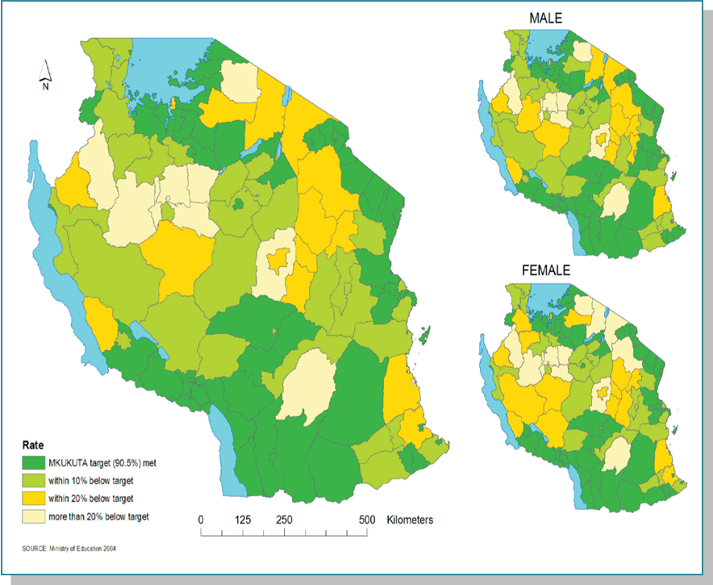
The issue of attendance could be addressed by providing incentives for the children to attend school. The map provided above, Figure 1, illustrates both that males are more likely to be educated in primary school than females, and that there is still an overall inability for areas of the country to meet the 90.5% enrollment standard by MKUKUTA.7 MUKUKUTA is a Kiswahili acronym for the National Strategy for Growth and Reduction of Poverty, and is a reform program which is currently in a 5 year phase (2005-2010).
Primary school provides only the basic educational tools that people can use to create new ideas and improve their society. As in most underdeveloped nations, Tanzania has an issue with quality of education. For Tanzania to reach a higher standard of education the number of schools available must be increased, and the overall quality of the schooling must be improved as well. Increasing the number of teachers per student could be beneficial to increasing the education quality.

Health

Infant Mortality Rates

High infant mortality rates in Tanzania are a result of many health issues that plague the daily lives of Tanzanians. The country’s infant mortality rate of 72 infant deaths per one thousand is extremely high. 2 Neighboring Kenya’s infant mortality rate is under 58 deaths per one thousand, and illustrates the ability for improvement within the region of East Africa.2 South Africa’s infant mortality rate is a surprisingly high at 60 deaths per one thousand. Though this figure is lower than Tanzania’s, it illustrates the point that higher GDP does not guarantee a higher standard of living, and emphasizes why GDP and economic growth alone cannot be sufficient in judging development on the whole. The differences in these numbers, as well as the fact that Tanzania has the twenty-eighth highest infant mortality rate in the world, illustrates the necessity for further improvement by Tanzania.2

Any human, regardless of the nation they are born into should have access to legitimate medical aid. Globalization allows for easier transfers of the medical resources and knowledge that can help Tanzanians improve their health standards. As a result, Tanzanians should be able to have access to similar medical care available to first world countries. Although Tanzania’s infant mortality rate is lower than some other neighboring African nations, such as Malawi (about 92/1000) and Mozambique (about 109/1000), it is still at an unacceptably high rate.

Figure 2: Under-five Morality Rates by Province:

Figure 3: Amount of Health Facilities Per Province

Figure 2, above, displays the under-five infant mortality rate by province.7 It is important to recognize the direct correlation between this map and Figure 3 below it. This parallel shows that infant mortality decreases as the number of health facilities per district increases.7 Infant mortality rates are generally worst in the southeast provinces of Tanzania, which have very poor access to health facilities, road infrastructure, and clean water supplies. Medical facilities in Tanzania face major problems when attempting to provide health care because there is less than one doctor per every thousand people in some areas. South Africa has about 1 doctor per every thousand people, a large improvement over Tanzania.1 Increasing the amount of qualified physicians available would result in a decrease in the infant mortality rate.
In Tanzanian society, a large portion of a woman’s identity is dependent on her offspring. Men are generally head of the household, while women earn their respect through their children. In many communities a girl is not considered a woman until she gives birth to a healthy child. Some women even take the name of their first born child and are called “Mama Abasi,” for example. A woman’s pride and identity that she gets through her children is very significant to her life. High infant and child mortality rates, therefore, could lead to mental instability of women and a weakening of community productivity and cohesiveness. Increasing the amount of qualified, practicing physicians, and increasing the number of health facilities can help alleviate both this problem and others caused by high infant mortality rates.

Life Expectancy
Another health-related issue for the population is life expectancy. The average life expectancy in Tanzania is roughly 50 years old, ranking 194th out of 222 countries. It has remained at this level since 2000.2 Kenya’s life expectancy is 55, a modestly higher but certainly a substantial margin as it is represents a life span 10 percent longer. Tanzania should strive towards this better figure. Although South Africa has a stronger economy than both Tanzania and Kenya, the average life expectancy for a South African is only 42 years old. These statistics are again evidence why development potential cannot be based solely on increases in GDP per capita and other economic factors. When compared to the 77 year life expectancy of the average American, all of these statistics are unacceptably low. Causes of shorter life expectancies in Tanzania include rampant diseases such as cholera, malaria, and HIV/AIDS. Improvement in fighting and warding off diseases would lengthen life spans.

Disease
Over 75 percent of deaths under the age of five in Tanzania result from pneumonia, diarrhea, measles, and malnutrition. The diseases children suffer can be prevented by better knowledge of hygiene and better access to clean water sources. The most common, and often preventable, diseases for the entire population include communicable diseases, reproductive disorders, childhood disorders, or non-communicable diseases which arise from lifestyle changes. Of the communicable diseases, HIV/AIDS is much more preventable through education alone than the most of the others; however, in 2005, 6.5 percent of the population still died of AIDS. Despite the high number of mortalities resulting from AIDS, the rate in Tanzania was significantly lower than that of South Africa, which stands at 18.8 percent.6
Malaria is another easily preventable disease. Unfortunately, it kills approximately 100,000 Tanzanians per year. In neighboring Kenya, malaria is the cause of about 34,000 deaths each year. South Africa suffers many fewer deaths due to malaria; in 2004 there were only 423 deaths. Prevention of Malaria is as simple as using a mosquito net or insecticide while sleeping. The average Tanzanian, however, is either uneducated about the prevention methods or unable to access them.

Nutrition and Malnourishment
Good nutrition provides children with the energy and resources to establish a healthy and strong society. Reducing malnourishment among the children of Tanzania can substantially increase developmental potential. Almost 25% of children under the age of five are underweight, and therefore lack energy which could otherwise be used toward paying attention in school or helping around the house. In Kenya just less than 20% of the population is undernourished. Although this number is still high, it again serves as a model for Tanzania.2 Mental development at these young ages is crucial, and dietary deficiencies deprive individuals of the capability to reach their full physical and mental potentials. Two of the most prominent consequences of malnourishment include Iodine deficiency and anemia. Iodine deficiencies can result in serious issues such as goiters and cretinism, in turn causing mental retardation and the loss of IQ points. Anemia can result in heart palpitations and failure. Another effect of malnourishment is stunting, which is the literal prevention of development in children because they lack access to enough nutrients and calories. Figure 4, below, displays stunting as a percentage of children by province.5 The prevalence of mental retardation and heart failure due to malnourishment are barriers to improvement in any nation. Tanzanian children cannot physically or mentally develop with the prevalence of malnourishment limiting their capabilities; such a problem will continue to stunt future generations and societies if the conditions are not improved. A healthy society is one that has reached a level of development in which its citizens are able to work to their full potential.

Figure 4: Stunting as a Percentage of Children by Province:

Basic Needs

Shelter
Shelter is a basic human need that is intertwined with both health and standard of living. Shelter provides sanitary living conditions and protection from disease spreading mosquitoes. Homelessness plagues Tanzania’s flood plains, rural areas, and urban areas where slums have become one of the primary sources of housing. In 2006, a major flood left 19,000 Tanzanians homeless in the northern portion of the country. Although this flood is a singular example, the issue of flooding is a consistent threat for several flood-prone areas of Tanzania. Slums provide neither sanitary health conditions nor sanitary water access.

Table 3: Urban Population in Slums
Country/Area | % of Urban Population Living in Slums
Tanzania | 92.1
Kenya | 70.7
South Africa | 33.2
Sub-Saharan Africa | 72.5
Developing Countries | 43.4
Developed Countries | 7.5

As the table above shows, the percentage of Tanzania’s urban population living in slums is much higher than other countries and the average of Sub-Saharan Africa. Because 23% of Tanzania’s total population lives in urban areas, of which close to 20% live in slums, this lack of housing requires intervention by either the government or a NGO to provide suitable shelter to those who lack it. Without such action, people will not be able meet their basic needs, and consequently not focus on reaching their potential, obstructing the development process.

Water Access
Along with food and shelter, access to water is essential to fulfill basic human needs. Sanitary drinking water can decrease under-five child mortality rates because it reduces diarrhea and water borne illnesses that are contracted through drinking unsafe water. Due to its location adjacent to the Great Lakes region, including Lake Victoria which is the second largest fresh water lake in the world, Tanzania should hypothetically have access to enough water to serve its population.

Figure 5: Tanzania’s Main Waterways and Lakes
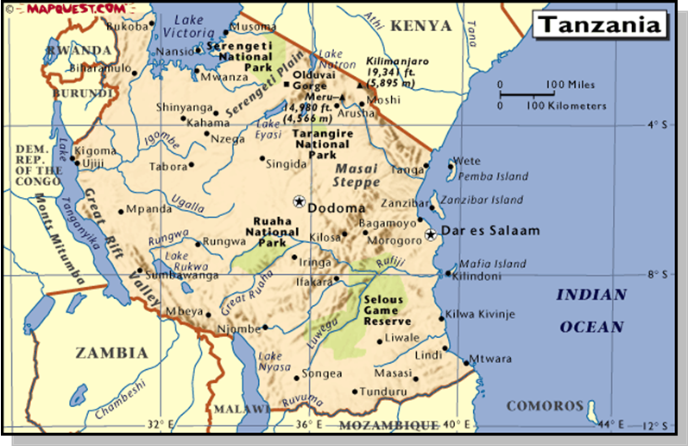
A map of Tanzania and its waterways can be seen in Figure 5. Lake Victoria sits in the Northwest corner of the country and separates the two great rift valleys. It is also next to a giant central plateau that is more than 2000 meters in elevation. The plateau has an altitude much higher than that of the Rift Valley, which prevents easy access to water from the Great Lakes that would otherwise be possible. This is due in part to a lack of necessary infrastructure which could provide water to these higher elevations. A sizable amount of the population lives on rural plains within this plateau, where the climate is extremely dry. Tanzania has many issues connected with water distribution, irrigation, and agriculture because of this inability to supply potable water to this area. Along the Northeastern border lies a significant mountain range, which includes Mt. Kilimanjaro, the tallest mountain on the African continent. The climate in most areas is tropical with very unreliable amounts of rainfall. The dry season brings drought and rainy season brings flooding which create difficulties for farmers and are therefore significant issues in much of Tanzania where people rely on domestic food sources or grow their own food. In the northern areas there is a cycle of two rainy and two dry seasons per year, while in the south there is only one of each per year. All of these physical and climate related challenges make access to clean water as well as domestic farming difficult.
Of the approximately 1 million square kilometers of Tanzania’s land area, only between four to six percent of the land is arable, usable for agriculture. Considering that 89% of the country’s total water usage is put toward agriculture, it is surprising that only four percent of arable land is irrigated. A serious problem is the amount of available water despite Tanzania’s proximity to large water supplies. The government has only recently made an effort to encourage and back large scale irrigation reforms and attempts to improve small scale irrigation systems.15 As described by the International Commission on Irrigation and Drainage, traditional irrigation schemes that are still used in Tanzania have been proven inadequate in today’s society because of “(i) sharp increases in population, (ii) fair wear and tear, and (iii) catchment degradation and other environmental problems such as waterlogging and salinity.” Below, Table 4 shows the amount of land used each by small landowners, government land, and large companies. Table 5 then presents the amount of land that is irrigated and the type of irrigation that is used. 16
Table 4: Types of Irrigation in Tanzania
Farm Type | Area (number of hectares)
Estates, outgrowers, medium to large commercial farms | 2400
Parastatal/government farms | 19,700
Smallholder, small commercial | 359,000
Total area under Irrigation | 381,000
Potential total arable land | 40,000,000

Table 5: Methods of Irrigation in Tanzania
Type of Irrigation Used | Area (number of hectares)
Formal Irrigation | 26,000
Traditional Irrigation | 85,000
Natural flooding/water harvesting | 270,000
Total Present Irrigated Area | 381,000

The data in these tables illustrates that although very little land is irrigated, most irrigation that takes place is in the traditional style and is overall inefficient. The International Commission on Irrigation and Drainage points out that the largest problems with irrigation in Tanzania today are the lack or organization between the government, outside NGOs, and both small and large scale landowners. Table 6 below shows how significant the type of irrigation system can affect the yield of the land, and therefore points out the necessity of implementing reforms that will improve the situation.17
Table 6. Production on different types of existing schemes in Tanzania
Type of Scheme | Yield (tons of water per hectare) | Comments
1. Traditionally irrigated | 1.0-2.0 | Scheme comprises water harvesting and river diversions.
2. Improved traditional | 4.0 | There is River diversion and improved land development
3. New Smallholder | 2.0-6.0 | In this category some of the schemes are:  * Mechanized with high inputs  * Using modern varieties  * Having 3 crops in 2 years
4. Irrigation state farms | 3.0-4.0 | Schemes are high input packages, mechanised operations, modern varieties, but all single cropped.

An average woman and child in Tanzania spends more than two hours a day collecting water. It is not uncommon for Tanzanians to venture as long as six hours to the nearest water source. Making water more accessible would ease the burden of everyday life, improve the constant fight against diseases, and provide better irrigation to farms. It would also allow more time for those who once traveled to collect water to perform other tasks, such as going to school, raising children, and farming food for consumption.
There is a lack of arable land due to physical barriers despite the plethora of water that could supply Tanzania. The main question is whether or not water can be distributed more adequately through more advanced methods of irrigation. All of these aspects would advance Tanzania’s developmental process on the whole.

Energy
Energy supply, in particular that of electricity, remains a bottleneck in the development of Tanzania. Providing basic energy needs to the more remote regions of Tanzania would allow citizens to use electric lighting and appliances such as a land telephone. Currently, only 11% of Tanzania’s population has access to electricity, and the majority of those people live in cities. Of Tanzania’s 113 districts, 18 still do not have access to electricity.34 Connecting more regions of the country to the electric grid and ensuring the stable supply of energy would increase the potential for providing a range of resources from lighting a person’s home to the running of a hospital. By expanding the energy infrastructure of Tanzania, it is possible that more non-governmental organizations and international organizations could be attracted to aiding the development of Tanzania. Capital providers including NGOs and MNCs, which can facilitate development, are more likely to invest in areas with electricity.
In an effort to increase efficiency, the government decided in late 1999 to privatize their previously government-owned company and introduce competition into the energy sector. Currently, TANESCO, Tanzania’s largest energy provider, uses hydropower as its main source. Unfortunately this supply can be unreliable especially during times of droughts and flood. During dry spells energy must be rationed via the process of load shedding, depriving many citizens of electricity.35 Only five percent of the potential hydropower resources are currently used, suggesting Tanzania has a large amount of untapped potential.35 Improving the technology and distributional methods of energy in Tanzania would greatly improve the quality of life of the average citizen.

Economy
A full development is one that is multi-faceted and requires that standard of living increases be accompanied by general economic growth. True economic growth should not be focused on increasing GDP per capita alone, but rather focused on the improvement of employment rates, income distribution, economic diversity, and self-sufficiency. GDP per capita by itself is not a reliable source of economic growth because it does not take into account distribution of income; true economic growth should be determined at the individual level rather than on the aggregate level. With approximately 50% of the population unemployed, Tanzania is incapable of realizing its full economic potential.11 Increasing job availability would in turn aid the reduction of unemployment rates. A lack of employment has a detrimental effect on not only the economy, but also the individual. Being employed brings a personal pride. People cannot strive for a sense of accomplishment and success in the ability to provide for one’s family without a steady income. Honor and pride are major concepts in African lifestyle, so improvement of employment rates will motivate people toward further growth and development. Increasing GDP per capita may be a side result of the greater achievement that comes from restoring honor, pride, and a sense of accomplishment; however, it will not be an overarching, free-standing goal.

Economic Distribution
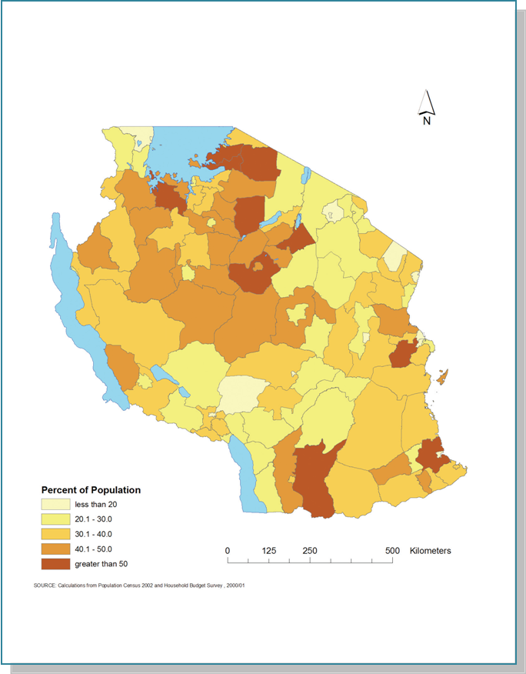
Along with the low levels of employment, an uneven distribution of income within Tanzanian society exacerbates the problem of poverty. In its 2000/2001 Human Development Report, the UN Development Program found that 36% of Tanzanians lived below the national poverty line, as shown in Figure 6 below. About 60% of the country’s population lives on less than two international dollars per day adjusted for purchasing power parity, and 20% live on less than one dollar per day PPP.16 The richest 20% of the population, on the other hand, earn 45.5% of the total income in Tanzania. It is precisely because of this inequity that GDP per capita is not a reliable measure of the economic position of the population as a whole. Creating a more even distribution of income in turn creates the greatest good for the greatest number of people. It cannot be truly considered development if the standard of living improves for only the richest few in a nation. The best way to reduce this distributional gap is to improve the unemployment situation, because the poor are prevented from moving up in economic standing as long as they have no constant source of income. Improving employment levels would create a cycle of economic and social progress that would facilitate a higher level of development.

Agriculture
Currently, the overwhelming focus of Tanzania’s economy is on agriculture, primarily the production of cash crops, which takes up 80% of the country’s labor force. The agricultural industry, however, only creates 45.3% of GDP, which is a cause of concern because the percent of employment in the sector should roughly reflect the percent of GDP. It is interesting that despite the vast technological advances of the past 40 years, agriculture makes up the same percentage of GDP as it did in 1961. As Michael Lipton discusses in his paper Why Poor People Stay Poor: Urban Bias in World Development, much of the resources and funding in underdeveloped nations goes to the urban areas, which facilitates the higher productivity of the urban industrialized sectors in comparison to the rural agricultural sector. The lack of investment in rural areas caused by urban bias has led to poor productivity in agriculture relative to other urban sectors, especially considering the large amount of people it employs, and shows the significant problems caused by this situation. Therefore, there is a desire for a more diversified economy to reduce the reliance on the agricultural sector. Increased employment as well as reduction of Tanzania’s reliance on the export of primary products would come as a result of adding diversity to the economy.
While 17.4% of Tanzania’s GDP comes from industry and 37.3% of GDP comes from the service sector, an overwhelming majority of the workforce is concentrated into agriculture.11 The industrial sector of Tanzania’s economy has shown growth at a rate of 6.9% per year, which illustrates that progress is already underway. 10 It has grown dramatically since the 1960’s when industry accounted for only 7% of GDP. 20 Diversifying the economy would not only allow for more growth, but also create more economic flexibility concerning the production and exportation of primary products. The current concentration of agriculture and industry for export is troublesome because there is limited vertical mobility in the global market within the agricultural sector. International trade tends to benefit the foreign entity rather than the country in which primary products are being produced. Tanzania is a primary product producer, and therefore tends to be blocked out of the benefits reaped by such international trade with respect to promotions and profit distribution.
In addition to the lack of vertical mobility, Tanzania’s economy is in a poor situation because it focuses primarily on growing cash crops, which do not provide food for the people producing them. Coffee, tobacco, and cotton are examples of major crops in Tanzania’s economy, yet they fail to aid the major issues of malnutrition, caused by an obvious lack of food supply. If Tanzania were to have more subsistence farming and less cash crop production, it could then direct its production towards reducing the continuing problems of malnutrition. Considering the improvements in industry and the lack of forward mobility in the agricultural sector, movement away from cash crops and toward self-sustainability, even on a small scale, would be beneficial to the development of the nation.

Politics of Tanzania
In our attempt to determine Tanzania’s level of development, it is important to analyze the governmental system because all domestic policy, a significant aspect of development, is implemented by the government. In addition, inspecting the political history of the government provides insight into how, historically speaking, government lack of action in Tanzania is partly to blame for of its current state of underdevelopment. The United Republic of Tanzania, then named Tanganyika, won its independence from England in 1964 and has since been led by one party. It was at the onset of democracy in the early 1990s, however, that true government reforms began to arise and actually improve the state of development of Tanzania.

Political Parties
Tanzania’s political history, though stable when compared with its neighbors, has been dominated by the Chana Cha Mapinduzi (CCM) party, even since Tanzania instated full democratic elections in 1995. Although Tanzania appears to be democratic from the exterior because they have multiple parties and voters are free to elect whomever they choose, the process is neither free nor fair by international standards. The lack of real competition between political parties is displayed by Table 7 which shows the results of the 2005 presidential election.

Table 7: 2005 Presidential Election Results
Registered Voters | 16,401,694
Total Votes (Voter Turnout) | 11,875,927 (72.4%)
Invalid/Blank Votes | 510,450
Total Valid Votes | 11,365,477
Candidate (Party) |  | Number of Votes | % of Votes
Jakaya Kikwete (CCM) |  | 9,123,952 | 80.28%
Ibrahim Lipumba (CUF) |  | 1,327,125 | 11.68%
Freeman Mbowe (CHADEMA) |  | 668,756 | 5.88%
Augustine Mrema (TLP) |  | 84,901 | 0.75%
Sengondo Mvungi (NCCR-Mageuzi)* |  | 55,819 | 0.49%
Christopher Mtikila (DP) |  | 31,083 | 0.27%
Emmanuel Makaidi (NLD) |  | 21,574 | 0.19%
Anna Senkoro (PPT-Maendeleo) |  | 18,783 | 0.17%
Leonard Shayo (MAKINI) |  | 17,070 | 0.15%
Paul Kyara (SAU) |  | 16,414 | 0.14%
*Sengondo Mvungi was also supported by the Forum for Restoration of Democracy (FORD), National Reconstruction Alliance (NRA), Union for Multiparty Democracy (UMD), and United People’s Democratic Party (UPDP).

The government claims that the CCM party won 72% of the votes in the 2000 presidential election and over 80% of the votes in the 2005 election. Such high statistics exhibit the weakness in the democratic institutions that are the basis of Tanzania’s current government. Party violence and disruption have not been as tangible as in other countries in Sub-Saharan Africa, but do still exist. On the mainland of Tanzania, very little government oppression of other political parties is needed due to the strong monopoly of the CCM party. On Zanzibar, on the other hand, the CCM party barely holds the majority position. This is not generally a cause of strife for the CCM because of the relative autonomy of Zanzibar, which has its own house of representatives that make laws applying specifically to Zanzibar. Although trivial compared to several of its regional neighbors, Zanzibar had experienced some fraudulent action and violence by the CCM toward the increasingly popular opposition parties, most notably the Civic United Front (CUF). The most recent example of this was in 2001 when the CUF protested on the basis that the recent election had been rigged. During these protests, 22 people were killed, which caused great political unrest and cast doubt to the legitimacy of the CCM party’s claimed acceptance of democracy. Because of its small role in modern Tanzanian politics, political infighting is not significant enough to be accused of stunting or preventing development; instead the ineffectiveness of government policy should be scrutinized with respect to development.

Polity
According to the Polity IV Project, Tanzania remained at a -7 Polity score from its inception in 1964 until 1992. Because of the political liberalization that occurred during the early 1990’s, in which democratic elections were instituted, the country’s rating improved to a score of positive 2 by 2001. In the current polity report on Tanzania, the democracy level remains the same since 2001; however, because its autocracy level increased from 1 to 2, Tanzania’s polity score declined from 2 to 1. This change is most likely due to the increase of election margin for the CCM party, which took over 80% of the votes in the 2005 presidential election. In the current national assembly 275 out of the possible 323 seats are held by the CCM party. The second leading party, the CUF, comes close to challenging or even overcoming the CCM party in Zanzibar, yet still holds only 31 seats in the national assembly. In recent years the judicial branch has shown increasing autonomy in contrast with the CCM dominated legislative branch. Recognition of the significance and recentness of these changes may help to provide insight into some of the initial steps towards development. Because Tanzania is one of the few African nations without a very violent and corrupt political history, the average person truly does have an impact on the outcome of democratic elections. Therefore, a better education system is necessary in order to inform the average citizen and enhance the democratic system.

Democratic Reforms
After instating multi-party democratic elections, the economy improved because of reforms made by the government. As explained by the Economic and Social Research Foundation of the Tanzanian government, “It is estimated that in the political reform process in Tanzania, political parties, rather than other institutions have been the major vehicles bringing about reforms and a more expanded political space in the country.” Allowing other parties to participate in the government has led to the vocalization of previously unheard views regarding policies and reforms. In 1998 Tanzania implemented the National Poverty Eradication Strategy, focused on eradicating poverty and better representing the poor in government policy.41
Economic growth has occurred due to economic liberalization, as illustrated by rising levels of GDP per capita throughout the 1990s. In 1993, soon after multi-party democracy was introduced, the government passed legislation to abolish all trade restrictions except for petroleum products and goods restricted for health and security reasons. The implementation of this legislation has liberalized trade for Tanzania by removing restrictions that had previously inhibited foreign aid and investment as well as international trade. This act has encouraged external actors to participate in Tanzania’s economy, which as a result has helped provide resources which the government could not provide alone. This bill has also helped to reduce the chronic inflation rates that had plagued the currency, Tanzanian schillings, since the 1970’s. Rates of depreciation during this time period fluctuated anywhere from 0.5% to 68%. Since 1993, deflation has stabilized significantly, without surpassing 14% annually, although it still remains a problem.42
The Tanzanian government has adopted a fiscal policy to achieve and maintain fiscal stability and increase domestic savings.41 This policy reform is continuously being implemented and adjusted to maintain a recurrent budget and keep domestic savings above 1 percent of GDP. An insufficient domestic savings level forces Tanzania to rely on foreign investment for GDP growth and acquire investment from abroad. These policies are indicative of the progressive attitudes brought into the government through the multi-party democratic reforms of the early 1990’s.

Economic Issues and Analysis

Investment Levels
To ensure that Tanzania’s development is sustainable, economic development will accompany the project’s focus on improving living standards. The Harrod-Domar equation is used to calculate a countries ability to achieve economic development. This equation inspects the level of investment provided domestically through savings, and consequently addresses how much investment needs to be provided from abroad to attain a particular GDP growth rate. The factors of the Harrod-Domar equation include the desired growth rate of GDP, the gross domestic savings (as a percentage of GDP), and the gross capital formation (as a percentage of GDP). These factors, shown in Table 8 below, calculate the K (capital) factor, which states that each unit of output requires 2.92 units of capital.

Figure 8: Harrod-Domar Components (2000-2006):
Region | GDP Annual Growth (% of GDP) | Gross Capital Formation (% of GDP) | K (GCF/change in GDP) | Gross Domestic Savings (% of GDP)
Kenya | 3.48 | 17.57 | 5.05 | 10.95
Tanzania | 6.25 | 18.22 | 2.92 | 11.00
South Africa | 4.09 | 17.11 | 4.18 | 18.02
Sub-Saharan Africa | 4.50 | 18.93 | 4.21 | 18.05

Analysis of recent economic data from Tanzania indicates that the country’s savings rates are significantly lower than those of South Africa and Sub-Saharan Africa. During the same fifteen year period, however, Tanzania has achieved growth rates nearly 50 percent higher than both of these areas. From 2004 through 2006 Tanzania has experienced steadily increasing GDP growth of 6.7%, 6.2%, and 6.2% respectively. GDP is projected to continue growing at rates of 7.1 and 7.5% through 20081; therefore it is reasonable to anticipate a growth rate of approximately 7%.26
The average K value is about 5, indicating 5 units of capital are required to produce one unit of output. While Kenya’s gross domestic savings rate is nearly identical for the past six years, its K value is about 5. This indicates that Kenya’s annual GDP growth of about 3.5 percent per year can be financed domestically from savings. Tanzania, however, is growing at about 6.25 percent with their nearly identical savings. To accomplish this growth requires Tanzania to obtain investment from sources abroad because domestic savings is insufficient. That Tanzania has a K value much lower than 5, at 2.92, means that one unit of output requires 2.92 units of capital.
This one gap between domestic savings and investment required to achieve target growth rates proves that this growth is unsustainably high. This is the case because the money flowing into the country to attain such high growth rates must eventually flow back out of the country. Their current growth rates, which are financed from abroad, create two gap difficulties as a result of a growing number of government liabilities to repay this quickly amassing foreign debt. Tanzania acquires money from abroad in the form of FDI, loans, grants and foreign aid. Unfortunately, the lack of domestic savings causes this dependence on external financiers and contributes to the large debt that Tanzania currently has. Consequently, a sustainable long-term growth target should be lower than the current 6.25 percent growth and the target of 7 percent, possibly similar to the 3.48 percent growth that Kenya currently experiences.

Currency Levels
The “two gap” analysis deals with the difference between the necessary hard currency and foreign exchange available to a country. Analysis of the two gap shows whether a country is experiencing any financial imbalances which can affect sustainability. This analysis considers trade, balance of payments, reserves, and international debt among other balance issues.
The Tanzanian shilling has been decreasing at a relatively stable rate since the mid-nineties. The currency has hovered around a depreciation rate of 10% for the past decade. This depreciation is due to the relatively little demand for the Tanzanian shilling on the global market. Any demand for the country’s currency would be for trade purposes, yet the extent of Tanzania’s share of global trade is minimal. This can be attributed to the greater demand for imports within Tanzania than exports from Tanzania. This trade imbalance means currency is constantly fleeing Tanzania. Other causes of this currency outflow are the repatriation of foreign investments and the high demand for foreign food and energy. Quantitatively, the trade imbalance in 2006 saw Tanzania import 1,431 million US dollars more worth of goods and services than it saw export. This amounts to about 10% of GNI for Tanzania. Table 9 below showcases that consumption and production have significantly increased over the past twenty years; however, the current account balance is lower now that it was in 1986.

Table 9: Current Account Balance
 | 1986 | 1996 | 2005 | 2006
Exports: Goods & Services | 8.9% | 17.6% | 22.2% | 24.5%
Imports: Goods & Services | 23% | 30.5% | 30.4% | 36.7%
Resource Balance | -14.2% | -13% | -8.2% | - 11.2%
Current Account Balance | -11.3% | -14.5% | -9.7% | - 12.2%

Balance of Payments
The balance of payments summarizes all international economic transactions for a country. For the past three decades, Tanzania experienced a balance of payments deficit which indicates Tanzania’s unhealthy reliance on imported goods and services. As illustrated by Table 9, the current account balance has been fluctuating for the past twenty years but has remained above 9% of GDP. Although Tanzania has expanded its export production rates, exports still lag behind imports as percent of GDP.
Using 2000 as a base year, Tanzania’s terms of trade have fluctuated from 76 in 1986 to 72 in 2006. The year 2000 represents a base year with a projected terms of trade level of 100, this indicates Tanzania had a better trade balance in 2000 than in it did in 1986. Although there is a general upward trend over this twenty year period, which is a positive indicator, the level has actually dropped by 25% between 2000 and 2006, as illustrated by Figure 7.

Figure 7: Tanzania Terms of Trade (base year 2000)
The decline in terms of trade over the past several years indicates that prices of manufactured goods and other imports have increased, and therefore Tanzanians must now pay a higher price for the same amount of imported goods. To solve the declining terms of trade, increasing production of goods that were previously imported decreases the desire to consume imports. It is evident that Tanzania’s unfavorable terms of trade and current account balance are unsustainable and the country must either find more efficient ways to improve exports or consume fewer imports. While Tanzania’s balance of trade has fluctuated for the past two decades it has always been negative.

Exports and Imports
Currently, Tanzania’s main exports consist of coffee, cotton, and manufactured goods. On the following page is a chart, Figure 8, which illustrates the proportion in which these products have been exported over the past twenty years.
Figure 8: Export Levels of Tanzania
Coffee export rates, as a percentage of exports, have fallen since 1986.; they decreased from 50% of exports in 1986 to about 20% in 1996 and then down to 4% in 2006. In terms of percentage of total exports, manufactured goods have not fluctuated as much as the two primary products which Tanzania grows most of. Tanzania can stabilize its flow of exports by reducing its reliance on primary product exports which are subject to volatile demand. The fluctuations in primary product markets, such as the markets for cotton and coffee, create an unpredictable economic environment; a steady export rate could increase economic stability within the trade balance.
Since reducing imports could have negative effects on Tanzania’s global favorability for foreign investment, the best alternative would be to instead increase exports. Tanzania has been a member of the WTO since 1995, which has since helped spur growth in both imports and exports. The WTO, however, emphasizes the reduction of import restrictions and trade barriers through its policies. Its policy states that “Lowering trade barriers is one of the most obvious means of encouraging trade. The barriers concerned include customs duties (or tariffs) and measures such as import bans or quotas that restrict quantities selectively. From time to time, other issues such as red tape and exchange rate policies have also been discussed.” This is why limiting imports rather than increasing exports is neither the best nor easiest approach to improving the balance of trade deficit.
Import restriction would also be difficult to implement because a sizable portion of imports consists of food as well as fuel. Prices for both have been rising rapidly rising since the 1990’s. The chart below illustrates Tanzanian food and fuel imports from 1986 to 2006 as percent of GDP. Imports fell from 1986 to 1996 but now constitute a large portion of GDP consumption. Fuel and energy imports have almost tripled from 1996 to 2006. If Tanzania improved domestic food and energy production, their reliance on foreign imports could be reduced.

Figure 9: Fuel and Energy and Food Imports as a % of GDP:
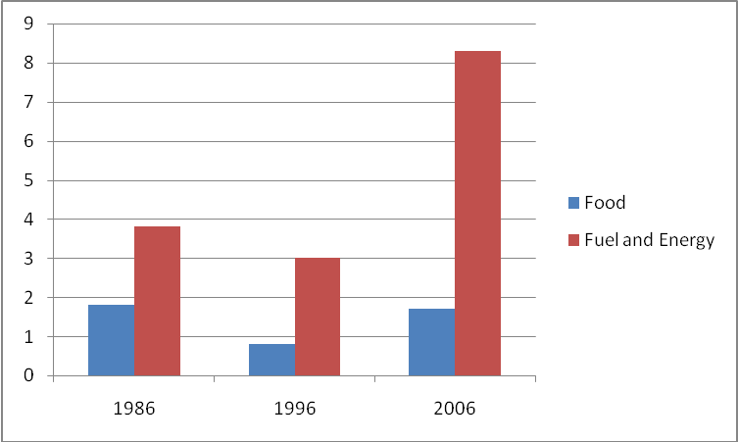

Foreign Aid
Tanzania is experiencing capital inflows from foreign direct investment and foreign aid. The inflow of aid in 2004 accounted for 16.17% of GDP, which was considerably lower than levels were in the 1980’s, but is still very high. The country is also experiencing capital outflows from debt and repatriated profits. Since 1988 the level of exported income has been decreasing. Although it reached its lowest point in 1996 at .86% of GDP, it has been hovering around 1.6% of GDP since.
Although FDI could feasibly be increased, at 26.78% of GDP in 2004, additional foreign direct investment could be detrimental.44 The tourism sector in Tanzania has proven to be lucrative and there is always the increasingly prevalent industrial and manufacturing sector of the economy. Both options have potential for foreign investment; however, considering that improvement of standard of living is the target, neither industry would benefit the country as a whole. Tourism is not a healthy industry for any country because the presence of wealthier foreigners can create resentment and a micro-society associated with the sector.
Financial flows into agriculture would provide greater benefits to the population as a whole. Doing so, would increase domestic food production which could reduce the need to import food. Investment in farming is more likely to distribute income and benefits evenly than investment into the industrial and tourism sectors will. Investment in these sectors is more likely to benefit the rich because they would exaggerate existing economic inequities.
Currency and trade level data point to similar conclusions. While the 1980’s was an extremely volatile time for the Tanzanian economy, looking at the political history of the country during this time period sheds light on why this may have occurred. The 1980’s saw the beginning of a transition from a one-party semi-democratic government to a multi-party more democratic government, whose first elections took place in 1995. The elections saw a government still dominated by the same party, and although the government was not able to turn the economy around imediately, it did act as a stabilizing mechanism for long term economic growth. Data relating to currency values and trade balances remained relatively stable, although not positive, through the late 1990’s and into the new millennium.

Foreign Debt
A major factor in any Tanzanian economic policy, or more specifically monetary policy, is the high level of foreign debt the country owes to sources abroad. As of 2005 Tanzania owed $3,861 million to the International Development Association and $342 million to the IMF alone. The total debt outstanding and disbursed in 2005 was $7,763 million. Long term debt in 2005 amounted to $6.3 billion. The government does not have a sufficient source of revenue with which it could feasibly repay its current foreign debts as well as continue to attempt social reforms for the country. The government budget deficit is increasing, as shown by its represnting 3.9% of GDP in 1996 and in 15% of GDP in 2006.
Tanzania is one of the top recipients of foreign aid in Africa. Because Tanzania suffers from a large foreign debt it must contribute 24% of its GDP toward the repayment of debts each year. Debts have consisted of nearly 75% or more of annual GDP since 1998. Tanzania has limited government expenditures because of this extremely high national debt level. National debt stock at the end of 2005 was 79.2 percent of GDP, an increase of 2.4 percent from the previous year’s end. Only 20.4 percent of this debt represents domestic debt, while 79.6 percent accounts for foreign debt. Nearly all of this domestic debt, 99 percent, results from the sale of Government securities. The fluctuation of such securities caused the domestic debt to increase 18.3 percent between 2004 and 2005. The external debt, on the other hand, only raised 1.1 percent over the same time period.
The Highly Indebted Poor Countries (HIPC) initiative has allowed for debt relief aid of 3.2 percent of GDP from various loaners as of the end of 2005. Regardless of this relief effort, Tanzania still has major debt problems that increase in size and accumulate interest as each year passes. This level of debt is in no way manageable or sustainable should Tanzania be expected to pay all debt back in full. Because the government’s debt level is so extreme, repayment of all debt would require an increase of incoming revenues or a decrease of government expenditures.
The loans Tanzania receives may be necessary to facilitate development; however, the foreign debt provides another barricade to the improvement of quality of life in Tanzania because it ties up a sizeable amount of government resources. International forgiveness of foreign debt or finding a different way to attain economic assistance is necessary for helping the development of this underdeveloped debtor nation.

Government Revenue and Expenditures
Government revenue in Tanzania has increased and become more effective since the implementation of a new Income Tax Act in 2004. Over the span of seven months during 2005-2006, there was an actual domestic revenue collection of 10.8 percent of GDP, equivalent to approximately US$0.11 billion monthly, a 17 percent increase over the amount collected the prior year. Tax-revenue dominates this domestic revenue collection, making up 92.1 percent, while only 7.9 percent of total revenue comes from non-tax revenue. The new Income Tax Act of 2004 has progressively improved the acquisition of tax revenue by making tax administration more effective. The government has also moved toward the taxation of imports and sales of domestic goods (also known as Value Added Tax), rather than a tax on income. A tax on goods is more effective than income taxes because the rich often evade taxes and the poor have little to no income to tax. If the improvements continue to gain effectiveness, what normally takes seven months to earn will now take only two months.
Existing government expenditures for which tax revenue is collected are well thought out and are moving in the right direction. As explained by the Tanzanian government’s General Economic Review, “Government expenditure policies for 2005/06 focused on enhancing and sustaining good financial management in order to facilitate achievements of national objectives of promoting economic growth and poverty reduction, as envisaged in the National Strategy for Growth and Reduction of Poverty (NSGRP).”49
The “three gap” in economics is defined as the gap between necessary expenditures and available revenues. The government needs to be able to collect enough revenue in order to provide the basic needs and reforms the country requires. Out of the US$0.11 billion collected monthly from tax revenues, however, the government plans to spend US$0.30 billion per month on government expenditures. This equates to a yearly total of 28.9 percent of Tanzania’s total GDP. It is then expected that 66 percent of this 28.9 percent be for recurrent expenditures, while only 34 percent are used for development expenditures.49 Recurrent expenditures most likely include the 40 percent of total government expenditures used on debt repayment each year. This high amount of debt is inhibiting the country’s ability to facilitate improvement because rather than budgeting for social reforms that would otherwise help develop the country, it is using 40 percent of its total expenditures on debt.
Although Tanzania’s debt position is discouraging, the government should be praised for its allocation of resources and its efficiency in collecting revenue. The new tax reform has provided tremendous improvement to tax revenues, and the only option for enhancing revenue is to continue moving towards taxing imports rather than income. Tanzania’s main priority should be neither to cut spending nor utilize revenues more efficiently, because the budgetary allocation for 2005-2006 was well balanced. It focused the most of its resources toward infrastructure and the transport/communication sector, 10.1 percent, closely followed by education at 7.7 percent and the health sector at 6.4 percent. Major increases in allocation to these sectors are also worth noting. There was over a three percent increase in revenues allocated to both education and health than in the previous year. The rest of the revenue is distributed fairly evenly (between about 2 to 3 percent each) between agriculture, security, mining, and economic services. Another noteworthy action is that 32.3 percent of the revenue allocated to agriculture is specifically directed towards research, showing Tanzania’s desire for progress and growth.
Tanzania’s government is well organized and moving in the right direction toward development; however, foreign debt is the main issue standing in the way. Because tax revenue is collected efficiently and allocated in a logical manner, growth should come naturally. Unfortunately, this progress is stunted by the massive burden of Tanzania’s ever-growing foreign debt. For example, Table 10 shows the correlation between the amount of money allocated toward health and the differences in debt levels among South Africa, Kenya, and Tanzania.

Table10 : Government Health Expenditure v. Aid Level
Country | Health expenditure per capita (US$) | Health expenditure as percent of GDP | Aid (%of GNI) | Aid (% of gross capital formation)
Tanzania | 12 | 4.0 | 12.2 | 65.8
South Africa | 390 | 8.6 | 0.3 | 1.6
Kenya | 86 (WHO) | 4.1 (WHO) | 4.0 | 24.4

Of the US$12 spent on annual per capita health expenditures, approximately $4.95 comes from the public sector and $6.50 comes from the private sector.50 Also, the following chart shows how there is a similar relationship between debt and both quality and quantity of education.

Table 11: Government Education Expenditure v. Aid Level
Country | Public expenditure on education (%of GDP 2001) | Public expenditure on education (% total government expenditures 2001) | Primary school completion rate | Aid (% of GNI) | Aid (% of gross capital formation)
Tanzania | 2.1 | 7.7 | 54.2 | 12.2 | 65.8
South Africa | 6.1 | 18.1 | 98.7 | 0.3 | 1.6
Kenya | 6.6 | 27.5 | 95.0 | 4.0 | 24.4

The Tanzanian government has done its best to allocate an appropriate amount of funds to significant sectors such as health and education; however, because it is spending 40% of annual government expenditures on repayment of debt, this reduces the amount of money that could be otherwise allocated to these sectors. Although this burden is unavoidable, the Tanzanian government is working to counteract the problem and should continue in the positive direction it is moving with its reforms.

Conclusion
A combination of economic improvements paired up with the enhancement of multiple social sectors, including health, basic needs, education, and infrastructure, is what contributes to the multi-faceted term referred to as “development.” It is more significant to measure improvement in the quality of the life of the average Tanzanian than it is to measure advancement simply by increases in GDP per capita. It is also necessary to take into account the political situation of the nation, because without a coherent and uncorrupt political system, there cannot be movement toward social change. The economic situation cannot be ignored because of the way in which factors like product specialization and foreign direct investment either facilitate or stunt other aspects of growth and development. Tanzania in particular has a major problem with debt, which plays a huge part in determining the future potential for its development. Its economic policies, however, are consistently well thought out and improving over time as a result of the change to a democratic government system in the previous decade. Tanzania has taken great strides to advance its economy and increase quality of life in Tanzania but still requires further action to overcome its major financial setbacks.

Cover Image:
Images provided by:
http://www.nationalgeographic.com/adventure/photography/africa/tanzania/lions-maneating-4.html
http://www.kilimanjaro-hakuna-matata.com/village.jpg

World Bank Education Profile, statistics from 2005
World Bank Education Profile, statistics from 2000
Hatch, John. Tanzania, a Profile. New York, NY: Praeger Publishers, Inc., 1972.
World Bank – World Development Indicators – https://publications.worldbank.org/subscriptions/WDI/old-default.htm
The United Republic of Tanzania Poverty Monitoring - http://www.povertymonitoring.go.tz/mkukuta.asp
CIA World Factbook - https://www.cia.gov/library/publications/the-world-factbook/rankorder/2091rank.html
HDR – UNDP http://hdr.undp.org/en/reports/nationalreports/africa/tanzania/tanzania_2005_en.pdf
http://www.who.int/countries/tza/tza/en/
Everyculture.com – http://www.everyculture.com/Sa-Th/tanzania.html
Index Mundi (2003) http://www.indexmundi.com/g/correlation.aspx?v1=30&v2=67&y=2003&l=en
http://www.who.int/hac/crises/tza/background/Tanzania_Feb05.pdf
http://hivinsite.ucsf.edu/global?page=cr09-sf-00
http://www.iht.com/articles/2008/02/18/africa/prexy.php
http://www.irinnews.org/Report.aspx?ReportId=59587
http://www.health24.com/medical/Condition_centres/777-792-818-1802,13801.asp
UNICEF –Progress for Children – Child Nutrition http://www.unicef.org/progressforchildren/2006n4/index_easternsouthernafrica_table.html
IRIN News - http://www.irinnews.org/report.aspx?reportid=59017
EarthTrends - Population, Health and Human Well-being -- http://earthtrends.wri.org/text/population-health/variable-1311.html
Tanzania 2002 Population and Housing Census -- http://www.tanzania.go.tz/census/tanzaniatotal.htm
HDR – UNDP http://hdr.undp.org/en/reports/nationalreports/africa/tanzania/tanzania_2005_en.pdf
http://www.penfamtours.com/images/tanzania%20map.gif
International Commission on Irrigation and Drainage. www.icid.org/index_e.html
Food and Agricultural Organization (FAO) Statistical Yearbook; Country Profiles - Tanzania. http://www.fao.org/es/ess/yearbook/vol_1_2/site_en.asp?page=cp
International Commission on Irrigation and Drainage. www.icid.org/index_e.html
Food and Agricultural Organization (FAO) Statistical Yearbook; Country Profiles - Tanzania. http://www.fao.org/es/ess/yearbook/vol_1_2/site_en.asp?page=cp
Note that 1 hectare is equal to 10,000 square meters
International Commission on Irrigation and Drainage. www.icid.org/index_e.html
WaterAid America – http://www.wateraid.org/usa/what_we_work/tanzania/
The United Republic of Tanzania Poverty Monitoring - http://www.povertymonitoring.go.tz/mkukuta.asp
http://tanesco.com/
UNDP HDR - http://hdr.undp.org/en/reports/nationalreports/africa/tanzania/tanzania_2005_en.pdf - Percentage of population below the basic needs poverty line is measured in 2000/2001 figures by 262 Tanzanian Schillings per adult equivalent per day and comes from the National Bureau of Statistics (2001) Tanzania Household Budget Survey 2000/01 (national poverty level, not global).
EarthTrends 2003 – http://earthtrends.wri.org/pdf_library/country_profiles/eco_cou_834.pdf
CIA World Fact Book
The World Bank Group, 2006
Hatch, John. Tanzania, a Profile. New York, NY: Praeger Publishers, Inc., 1972.
Michael Lipton, Why Poor People Stay Poor: Urban Bias in World Development. Harvard University Press, 1977.
Results of Tanzania presidential elections 2005 - http://africanelections.tripod.com/tz.html
CIA World Fact Book - https://www.cia.gov/library/publications/the-world-factbook/print/tz.html
The Polity IV Country Report – Tanzania http://www.cidcm.umd.edu/polity/country_reports/Taz1.htm
The United Republic of Tanzania Poverty Monitoring - http://www.povertymonitoring.go.tz/mkukuta.asp
The United Republic of Tanzania Poverty Monitoring - http://www.povertymonitoring.go.tz/mkukuta.asp
Economic and Social Research Foundation of Tanzania (ESRF) – “Understanding Economic and Political Reforms in Tanzania” (p6) - http://www.gdnet.org/pdf/global_research_projects/understanding_reform/country_studies/proposals/Tanzania_proposal.pdf
IMF – Policy Framework Paper - http://www.imf.org/external/np/pfp/1999/tanzania/taztab.htm
World Bank - World Development Indicators – Tradedeficits.wpd
World Bank World Development Indicators – http://worldbank.org
IMF World Economic and Financial Surveys – GDP constant prices, annual % change http://www.imf.org/external/pubs/ft/weo/2007/02/weodata/index.aspx
TradeDeficits.wpd
http://devdata.worldbank.org/ict/tza_ict.pdf
World Trade Organization (WTO) - http://www.wto.org/english/thewto_e/whatis_e/tif_e/fact2_e.htm
World Bank – World Development Indicators – tradedeficits.wpd
Bank of Tanzania – Economic Indicators - http://www.bot-tz.org/Publications/EconomicIndicators/EconomicAndFinancialIndicators.htm
The Economic Survey 2005: General Economic Review (Tanzania Government) http://www.tanzania.go.tz/economicsurvey1/2005/part1/govfinance.htm
The Economic Survey 2005: General Economic Review (Tanzania Government) http://www.tanzania.go.tz/economicsurvey1/2005/part1/govfinance.htm
US Department of State
The Economic Survey 2005: General Economic Review (Tanzania Government) http://www.tanzania.go.tz/economicsurvey1/2005/part1/govfinance.htm
The Economic Survey 2005: General Economic Review (Tanzania Government) http://www.tanzania.go.tz/economicsurvey1/2005/part1/govfinance.ht

